[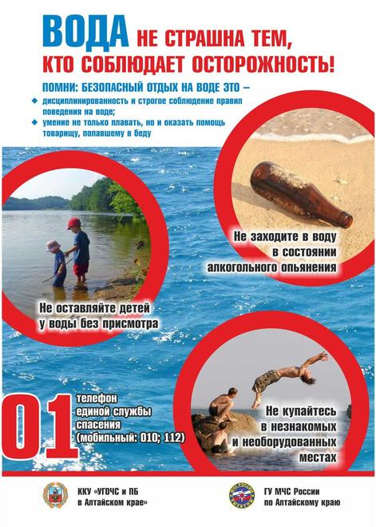](http://storage.inovaco.ru/media/cache/35/f6/c3/a9/b4/25/35f6c3a9b425696b2b7770c5cae9d625.jpg)